**Lab Assignments**

**Digital Image Processing**



Submitted by: Submitted to:

Ajay Singh Dr. Bhupendra Singh Kirar

(20U03058 ) (Professor)

Indian Institute of Information Technology, Bhopal

**Department of Information Technology**

Digital Image Processing (IT-312)

Bachelor of Technology

3rd Year, 5th Semster

**Index: Table of Content**

|  |  |  |  |  |
| --- | --- | --- | --- | --- |
| S.No | Assignment Name | Performance Date | Submission Date | Page No |
| 1 | Display color image in different RGB planes and extract all information about the image. | 21/01/2022 | 04/02/2022 | 3 |
| 2 | Extract Region of Interest of a skin cancer Image. | 21/01/2022 | 04/02/2022 | 5 |
| 3 | Convert your image to grey image then show the image in different intensity resolution. | 28/01/2022 | 04/02/2022 | 6 |
| 4 | Perform Shifting Interpolation in all direction on a given image and show all results. | 04/03/2022 | 11/03/2022 | 8 |
| 5 | Perform Rotation Interpolation in all direction on a given image and show all results. | 04/03/2022 | 11/03/2022 | 9 |
| 6 | Perform Shearing Interpolation on given image and show with original image. | 04/03/2022 | 11/03/2022 | 10 |
| 7 | Break your own image in different 8-bit planes and show with original Image. | 06/05/2022 | 11/05/2022 | 11 |

**Assignment 1**

a) Capture your own colour image and save it in .jpeg file format.

b) Convert colour image in RGB image.

c) Display colour image and converted grey image in a same figure.

d) Extract the complete information of the image.

**Solution –**

**MATLAB-Code:**

X = im2double(imread('Ajay.jpg'));

R = X(:,:,1);

G = X(:,:,2);

B = X(:,:,3);

z = zeros(size(R));

Rimg = cat(3, R, z, z);

Gimg = cat(3, z, G, z);

Bimg = cat(3, z, z, B);

subplot(3,2,1), imshow(X);

subplot(3,2,2), imshow(Rimg);

subplot(3,2,3), imshow(Gimg);

subplot(3,2,4), imshow(Bimg);

grayImg = rgb2gray(X);

subplot(3,2,5), imshow(grayImg);

info = imfinfo("Ajay.jpg");

imageinfo(info);

**Output:**

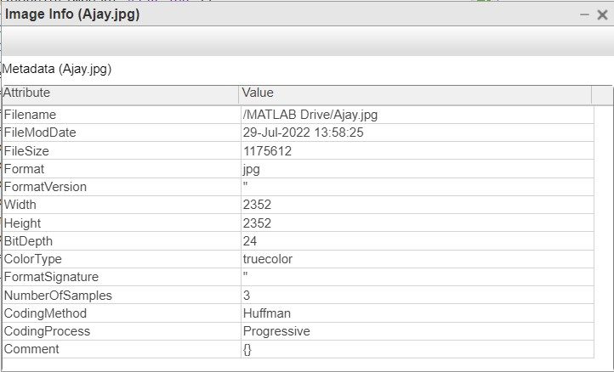

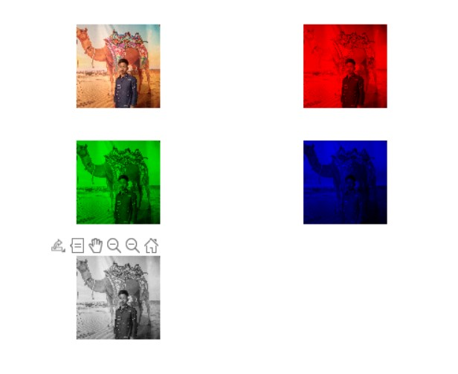

**Assignment 2**

a) Take an input image of skin cancer and increase the image quality using pre-processing techniques.

b) Extract the region of interest (ROI).

c) Download five images and run above programs with the help of loops for 5 images.

**Solution:**

**MATLAB Code:**

**Assignment 3 –**

a) Take your own picture and show it as it is.

b) Convert colourful image (RGB) to grey and show it.

c) Resize image to 256*256 pixels.

d) Display output grey images for different intensity resolution (256, 128, 64, 32, 16, 4, 2) in a single figure using subplot function.

**Solution:**

**MATLAB Code:**

I1=imread('Ajay.jpg');

I2 = imresize (I1, [256 256]);

I3 = rgb2gray(I1);

Subplot (3,3,1), imshow(I1);

Subplot (3,3,2), imshow(I3);

I3 = imresize (I3, [128,128]);

Subplot (3,3,3), imshow(I3);

I4 = imresize (I3, [64,64]);

Subplot (3,3,4), imshow(I4);

I5 = imresize (I3, [32,32]);

Subplot (3,3,5), imshow(I5);

I6 = imresize (I3, [16,16]);

Subplot (3,3,6), imshow(I6);

I7 = imresize (I3, [8,8]);

Subplot (3,3,7), imshow(I7);

I8 = imresize (I3, [4,4]);

Subplot (3,3,8), imshow(I8);

I9 = imresize (I3, [2,2]);

Subplot (3,3,9), imshow(I9);

**Output:**

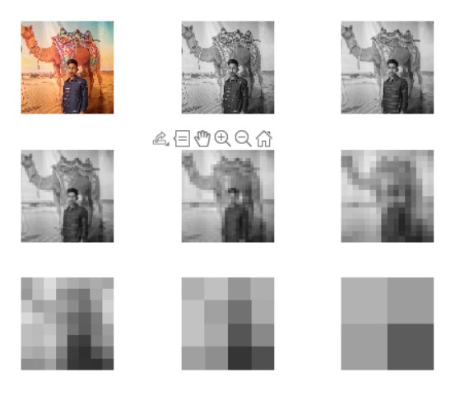

**Assignment 4**

a) Take any picture and show it as it is.

b) Convert colourful image (RGB) to grey.

c) Perform Shifting Interpolation in all direction and show all the results in same figure with the normal picture.

**Solution –**

**Shifting MATLAB Code:**

I = imread("cameraman.tif");

subplot(3,2,1),imshow(I),title("Original Image");

J = imtranslate(I,[15, 25]);

subplot(3,2,2),imshow(J),title("Translated Image");

K = imtranslate(I,[-15, 25]);

subplot(3,2,3), imshow(K), title("Trnslated Image");

L = imtranslate(I,[-15, -25]);

subplot(3,2,4), imshow(L), title("Trnslated Image");

M = imtranslate(I,[15, -25]);

subplot(3,2,5), imshow(M), title("Trnslated Image");

**Output –**

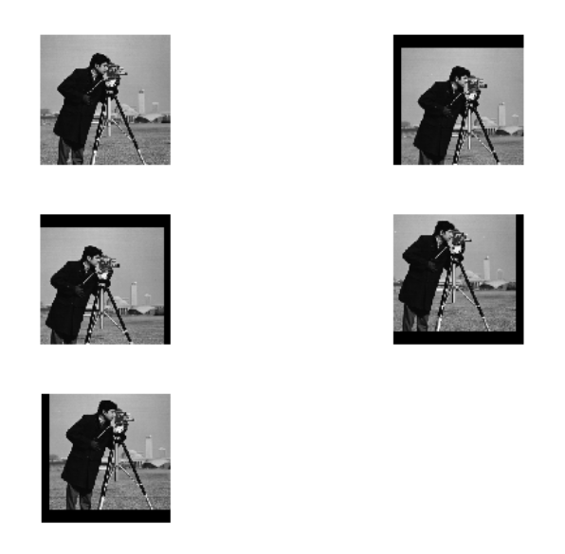

**Assignment 5**

a) Take any picture and show it as it is.

b) Convert colourful image (RGB) to grey.

c) Perform Rotating Interpolation in all direction and show all the results in same figure with the normal picture.

**Solution –**

**Rotating MATLAB Code:**

I = imread('cameraman.tif');

subplot(3,2,1), imshow(I), title("Original Image");

J = imrotate(I, 45);

subplot(3,2,2), imshow(J), title("Rotated Image 45degree");

K = imrotate(I, 90);

subplot(3,2,3), imshow(K), title("Rotated Image 90degree");

L = imrotate(I, 180);

subplot(3,2,4), imshow(L), title("Rotated Image 180degree");

M = imrotate(I, 270);

subplot(3,2,5), imshow(M), title("Rotated Image 270degree");

**Output –**

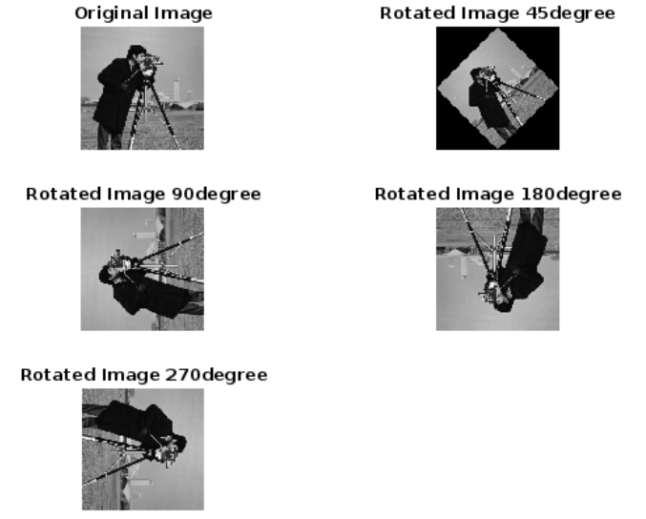

**Assignment 6**

a) Take any picture and show it as it is.

b) Convert colourful image (RGB) to grey.

c) Perform Shearing Interpolation in all direction and show all the results in same figure with the normal picture.

**Solution –**

**Shearing MATLAB Code:**

I = imread('cameraman.tif');

subplot(2,2,1), imshow(I);

tform = maketform('affine',[1 0 0; 0.4 1 0; 0 0 1]);

J = imtransform(I,tform);

subplot(2,2,2), imshow(J);

**Output –**

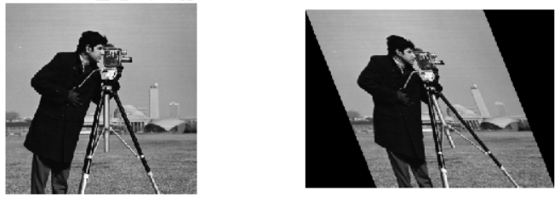

**Assignment 7**

a) Take your own picture and show it as it is.

b) Break the image into 8-bit planes and show all images in same figure with the original Image.

**Solution –**

**MATLAB Code –**

A=imread('Ajay.jpg');

A=double(A);

B=bitget(A,1);

subplot(3,4,2);imshow(B);title('Bit plane 1');

B=bitget(A,2);

subplot(3,4,3);imshow(B);title('Bit plane 2');

B=bitget(A,3);

subplot(3,4,4);imshow(B);title('Bit plane 3');

B=bitget(A,4);

subplot(3,4,5);imshow(B);title('Bit plane 4');

B=bitget(A,5);

subplot(3,4,6);imshow(B);title('Bit plane 5');

B=bitget(A,6);

subplot(3,4,7);imshow(B);title('Bit plane 6');

B=bitget(A,7);

subplot(3,4,8);imshow(B);title('Bit plane 7');

B=bitget(A,8);

subplot(3,4,9);imshow(B);title('Bit plane 8');

**Output –**

